Thesis status report

# week 06 - 07

## Done

I did a lot of research to find an application that consists of several microservices and would represent a real-world use case. OctoScan, the application that I wanted to use originally, turned out to not fit well to run the implemented benchmarks. I found the applications TeaStore[1], SockShop[2] and Robot-Shop[3]. First, I wanted to use the TeaStore because it is well documented. But after some benchmark runs, I found the application needed too many resources and was in general much too heavy for the use case. The SockShop was not well documented and was also implemented not with a local Kubernetes in mind. Finally, I decided to use the Robot-Shop because it has just the right amount of microservices and resource usage and already comes with a locust class, that emulates user behavior. I created an Overview of the microservice structure of the Robot-Shop (see figure 1).

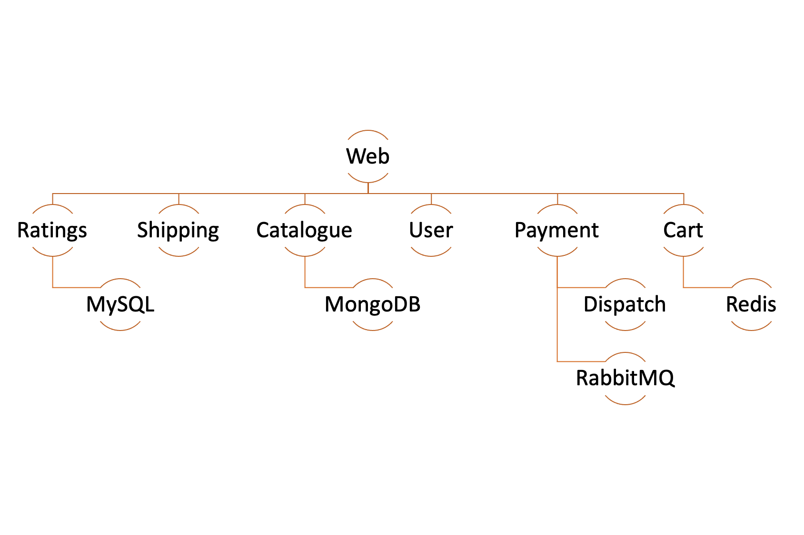

Figure : Robot-Shop microservice structure

I implemented several new methods to deploy the robot-shop and improved the benchmark itself. Deployments get now updated by being replaced and not only patched. This should prevent requests from overreaching from the previous run. Furthermore, I had to reimplement the formatting of the raw data. Now it can handle more than one pod.

I started to implement several machine learning approaches Linear Regression, Support Vector Regression and a simple neural network. I am using the mean values for every measured metric because it is then more comparable to the other approaches and Extra-P. I still have to figure out which parameters and kernel functions to use. Also, I have to find out which metric to use to compare the different approaches. Finally, I have to generate more test data.

## Update from sync meeting (19.02.2021)

?

## next steps

1. Improve machine learning model
2. Generate more test data
3. Implement the auto scaler

1. https://github.com/DescartesResearch/TeaStore
2. https://microservices-demo.github.io/
3. https://github.com/instana/robot-shop